## G H RAISONI COLLEGE OF ENGINEERING & MANAGEMENT, WAGHOLI, PUNE

**(An Autonomous Institute under UGC Act 1956 & Affiliated to Savitribai Phule Pune University)**

# EXPERIMENT NO. 4

# Perform simple Linear Regression using Data Analysis Toolbox of Excel or with python and interpret the regression table.

# AIM OF EXPERIMENT: Perform simple Linear Regression using Data Analysis Toolbox of Excel or with python and interpret the regression table.

**Date of Performance:** 19/03/2020 **Sign of Teacher:**

**Name: Swayam Terode Roll No. : C70**

**Division: C**

# AIM: Perform simple Linear Regression using Data Analysis Toolbox of Excel or with python and interpret the regression

# Table.

# What is Linear Regression?

# Linear regression is a linear model, e.g. a model that assumes a linear relationship between the input variables (x) and the single output variable (y). More specifically, that y can be calculated from a linear combination of the input variables (x).

**PRODECEDURE:**

This performed practical is helpful for understanding **Linear Regression using Data Analysis Toolbox of Excel** on given data set using descriptive statistics toolbox of excel.

1. **Enter the data in excel sheet**. The Data should not be empty.

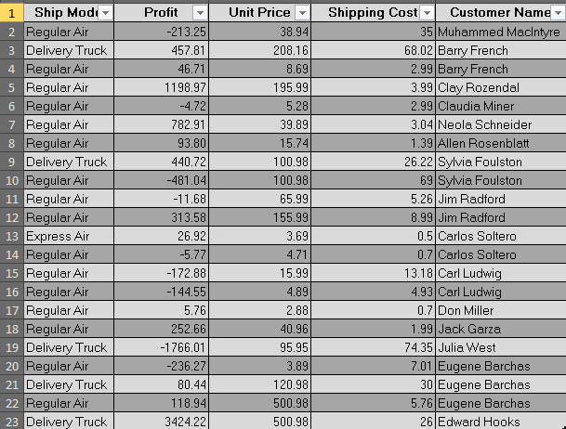

1. Click on **Data Tab** and then click on **DATA ANALYSIS.**

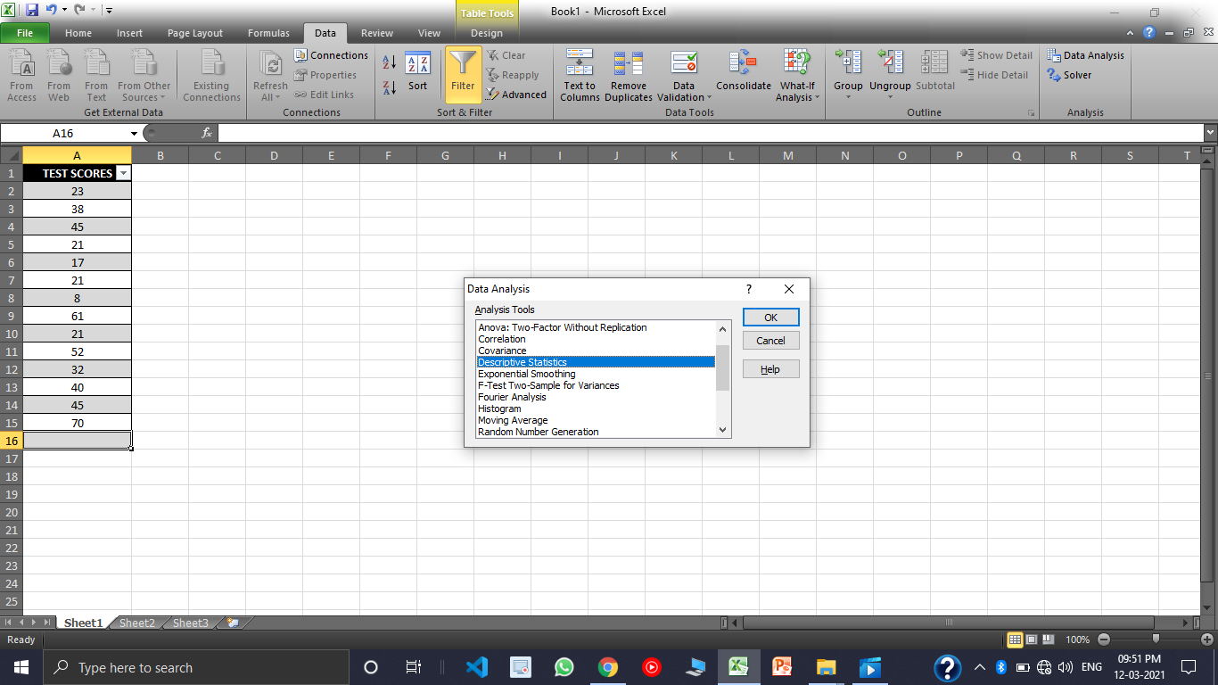

1. Clicking on this **Data Analysis** this dialogue box would appear, select **Regression** and click on **ok.**

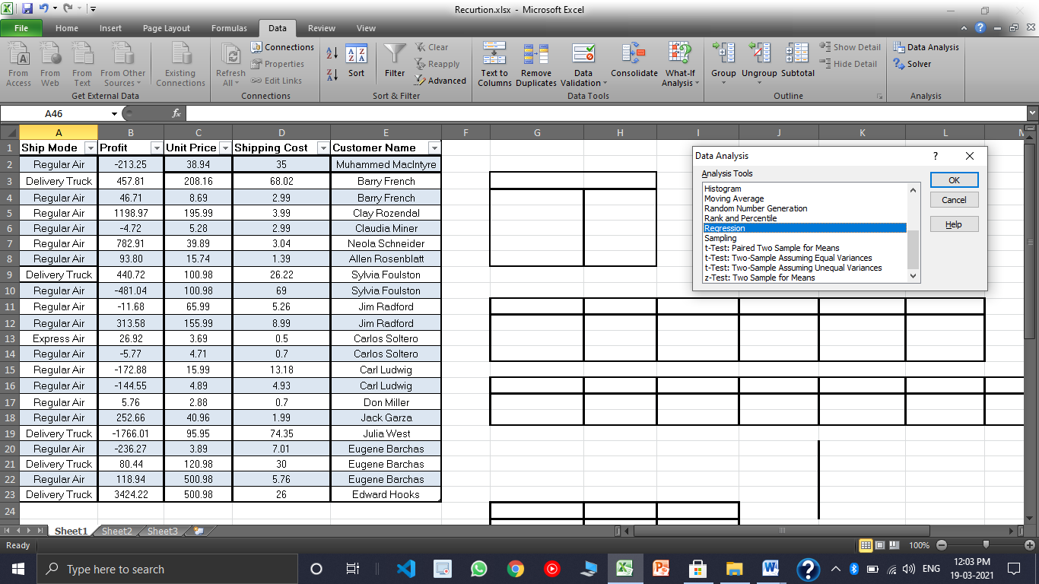

1. Input the Input Y Range and Input Range X also select the Output Range. **Remember the Input Range should be numeric value.**
2. Input the **Output Range** Select the **Residuals, Residual Plots, Line Fit Plots and Normal Probability Plots.**

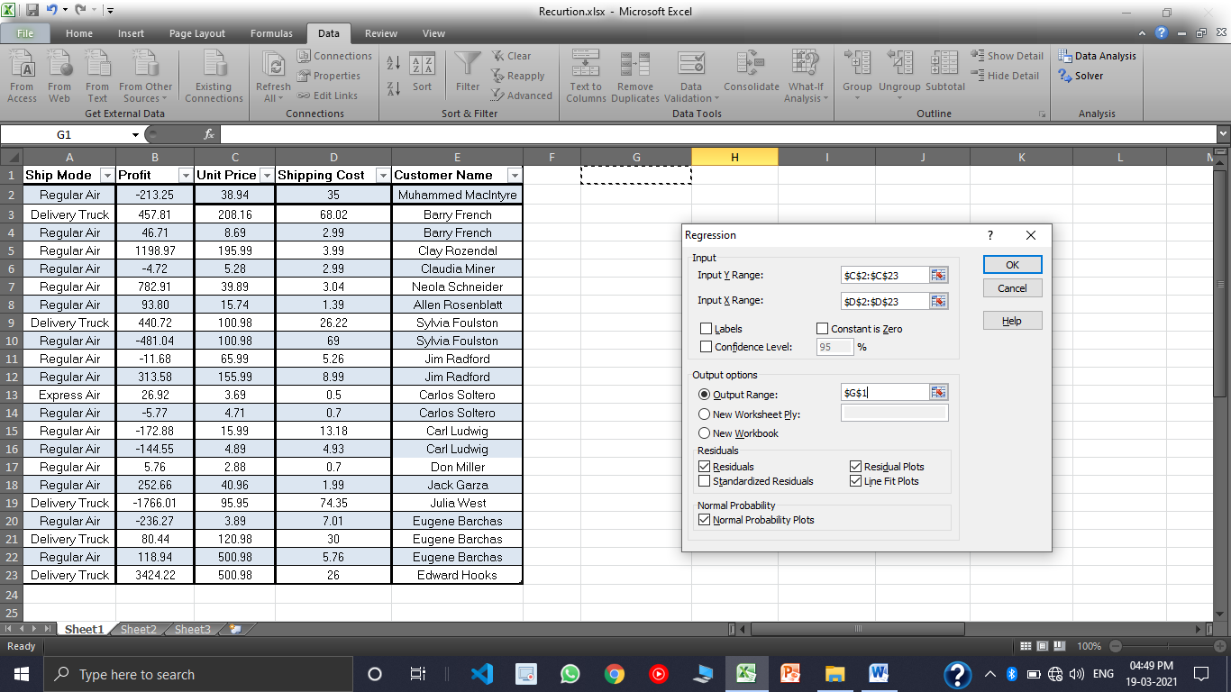

1. When you click on OK your Result would appear.

**RESULT:**

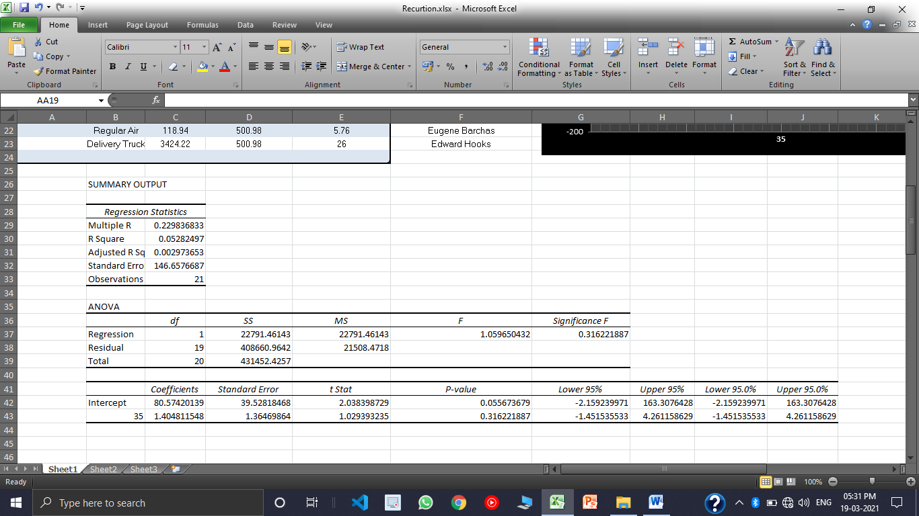

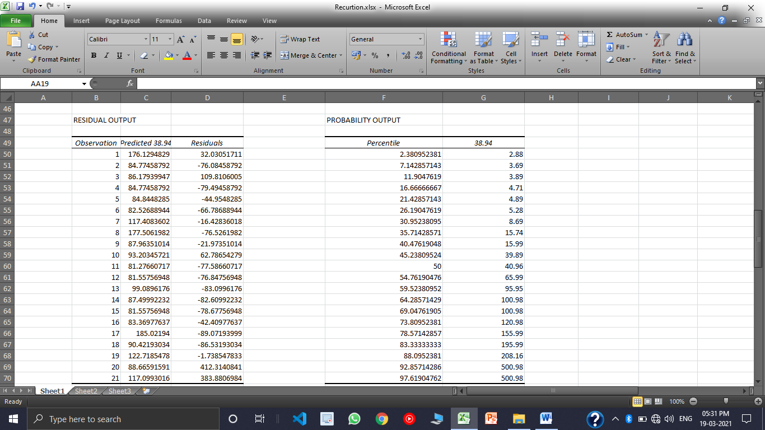

**PROBABILITY OUTPUT TABLE**



**UINT COST + SHIPPING COST GRAPH**

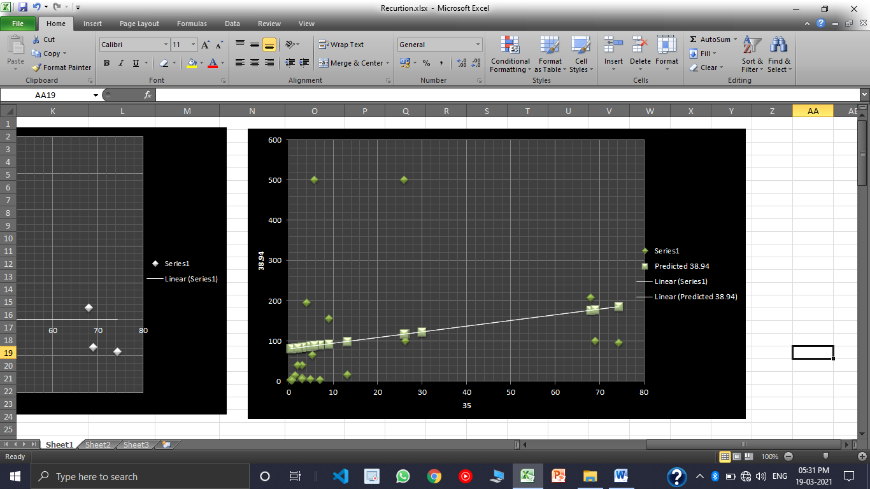

**SHIPPING COST GRAPH**

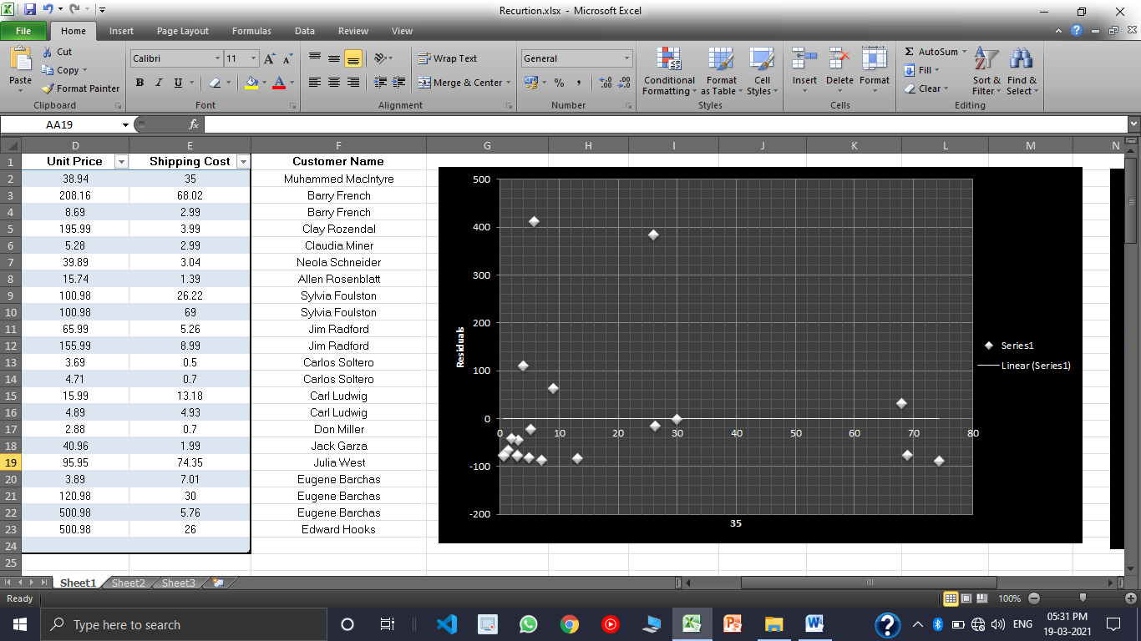

**PROBABILITY OUTPUT**

